**Individual research document**

OFS Platform

By Mohammed Al Harbi

28/09/2022

# Preface:

Mohammed Saleh Al Harbi, IT Fontys student. I have always been fascinated in technology since 2011, back then I broke my arm twice which resulted in me not doing sports anymore and began my first step in game development and my coding ability as hobby. In my high school graduation I received good marks that allowed me to obtain a scholarship to study abroad. In Fontys, I have studied application developments for 3 semesters, artificial intelligence for 1 semester and an artificial intelligence internship semester in Insify which is ranked 8th fintech insurance company that is valued between $66-$100 million. The moment this document is written is my 6th semester which revolves around application development.

# Project goal:

* To create a web application platform that facilitates the provision and reachability of services in Oman.

# Why ?

Having such platform would result in a clear vision where to look for services saves energy and time. There is no unified known platform in Oman for providing services regardless of its kind. People usually spend time going to the city centre looking for people with certain professions to get served. Additionally, unemployed graduate segment can provide their services instead of wasting time or staying idle until they are recruited.

# Initial basic architecture outcomes:

There are 3 important terms which needs to be clarified:

Monolithic web application architecture: This architecture contains all business logic in one unit.

Micro-services web application architecture: This architecture breaks down business logic into multiple microservice.

Below I have included my own diagram to clarify both architectures:

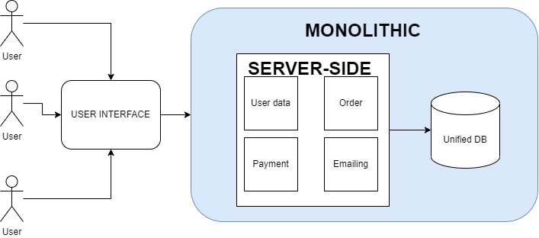

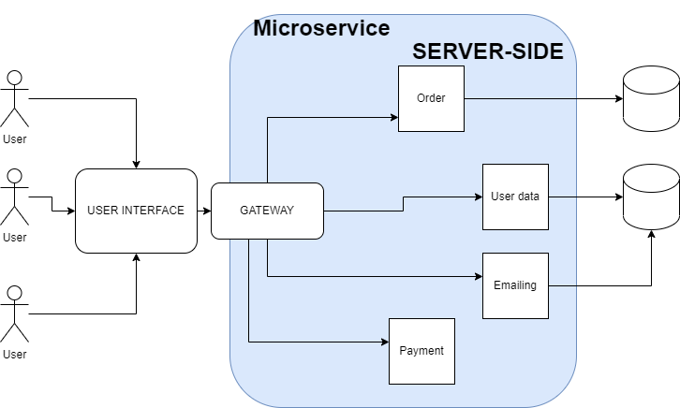

Another keyword I must mention is serverless which suits well in OFS platform as discussed with technical teachers initially, Below is an example of how the architecture of the application looks like:

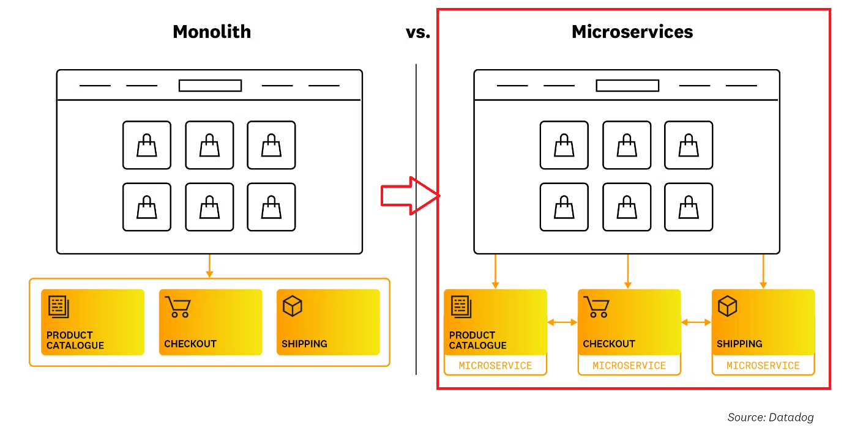

Above diagram clarifies how a serverless AWS microservice looks like.

Back in semester 3 I created a platform for exchange experiences for universities which was a monolithic web application. After looking at the learning outcomes of semester 6 utilizing microservices is a must, due to its ability to provide maintenance (one microservice breaks would not result in other microservices fail, which is not the case for monolithic application) and the scalability.

# Non-functional requirements:

The system shall be:

* Secure
* Scalable & maintainable
* Available
* Responsive
* Cost-efficient

# Project architectural conclusion:

Developing the web platform in a serverless microservice approach aligns well with the learning outcomes since it allows me to learn to utilize cloud services & improve application security & allows infinite scaling & forces me to learn new technologies and applies best code practises

# Research questions:

Based on the previous points and the learning outcomes, the following research question should help me achieve those learning outcomes. I must mention that those are the only research questions I see good fit but I might have missed an important point that need to be addressed. The way I clarified those questions is by having the **main research questions** followed by **headline titles** which can have **multiple sub-questions.**

1. What are best practical implementations of micro-services ?

* API Gateway
* Secure communication among microservices
* Multitude of databases vs unified database

1. What is the best fit serverless vendor for OFS platform ?

* Pros/cons of **Google Cloud** functions, **Azure** functions and **AWS lambda** functions
* Which vendor overcomes “Cold start” after idle the best

1. What is the most efficient approach to maximize the accuracy of utilized artificial intelligence model ?

* Experiments on summarization models using Natural language processing.
* Utilizing live-trained model(s) vs pre-trained model(s)
* Computer-vision for secondary login method & registration

1. Where and how to integrate google map API in developed microservices ?

* Study **Google Maps** API
* Study costs per request

1. How to integrate Bank muscat payment in the web application ?

* Online payment vs. Online traditional transfer
* Is there an API available to study & need contact proof and what is required procedure

1. What are the most prevalent type of services in Oman ?

* Service categories must include all common freelancing services
* Gather data for AI regarding average pricing for common services

# Timeline estimation:

The project can be split in 5 sprints:

Week 5 deliverables (sprint 1): A walking skeleton which allows communication between microservices.

Week 8 deliverables (sprint 2): CRUD functionalities of user & research costs/API and deployment documentation

Week 11 deliverables (sprint 3): Quaility test, CI, CD best practices and devOps

Week 14 deliverables (sprint 4): implementations and documentation of security measurements authentication and authorization and validation

Week 17 deliverables (sprint 5): complete platform, documents, domain, user tests results and final conclusion